

National University of Computer and Emerging Sciences



Self-Embedding Watermarking System

Arbab Hamd Rizwan…………18L-0756

Usama Aslam…………………18L-0972

Aashar Naseem.………………18L-1131

M. Hunzlah Malik……………18L-1139

Supervisor:Dr. Asif Mahmood Gilani

B.S. Computer Science

Final Year Project

June 2022

Anti-Plagiarism Declaration

This is to declare that the above publication produced under the:

**Title: ____Self-Embedding Watermarking System__________________**

is the sole contribution of the author(s) and no part hereof has been reproduced on **as it is** basis (cut and paste) which can be considered as Plagiarism. All referenced parts have been used to argue the idea and have been cited properly. I/We will be responsible and liable for any consequence if violation of this declaration is determined.

Date: _01-06-2022_____

Student 1

Name: Arbab Hamd Rizwan

Signature: _____

Student 2

Name: Usama Aslam

Signature: ___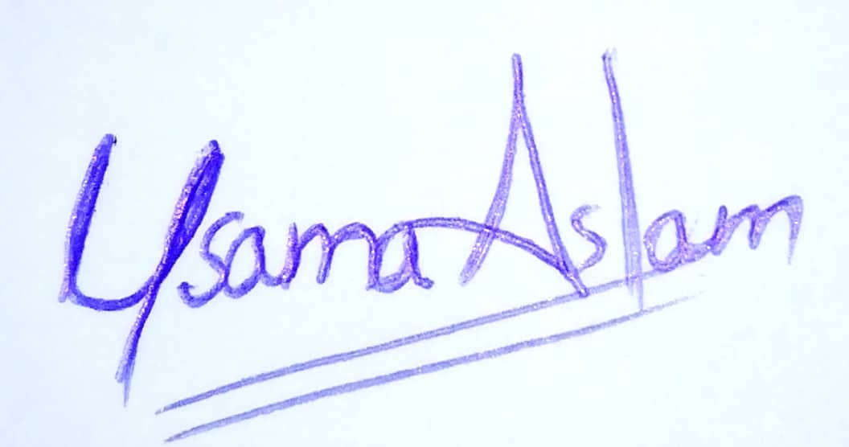_______

Student 3

Name: Aashar Naseem

Signature: _____________

Student 4

Name: M. Hunzlah Malik

Signature: ___________

Table of Contents

Table of Contents i

List of Tables iv

List of Figures v

Abstract 1

Chapter 1: Introduction 2

1.1 Goals and Objectives 2

1.2 Scope of the Project 2

Chapter 2: Literature Survey / Related Work 3

2.1 Image Watermarking 3

2.1.1 Triple Recovery Information Embedding Approach 3

2.1.2 Pixel-wise Authentication Based Self-Embedding Fragile Watermarking Method 3

2.1.3 Hash Function Based Fragile Watermarking 3

2.1.4 Fragile Watermarking based on Adaptive Selection of Embedding Mode 4

2.2 Video Watermarking 4

2.3 Spatiotemporal Trident Networks: Detection and Localization of Object Removal Tampering 4

2.4 Keyframe Extraction 5

2.4.1 Key-Frame-Extraction Based on Perceived Motion Energy Model 5

2.4.2 Cascaded Map Reduce Method 5

2.4.3 Keyframe Extraction Based on Dynamic Color Histogram 5

2.5 Lithops, a Multi-cloud Serverless Programming Framework 6

2.6 Conclusion 6

Chapter 3: Requirements and Design 7

3.1 Functional Requirements 7

3.2 Non-Functional Requirements 7

3.2.1 Performance Requirements 7

3.2.2 Security Requirements 7

3.2.3 Usability Requirements 7

3.2.4 Sustainability 7

3.2.5 Reliability 8

3.2.6 Extensibility 8

3.3 Hardware and Software Requirements 8

3.3.1 Hardware Requirements 8

3.3.2 Software Requirements 8

3.4 System Architecture 9

3.4.1 Image Authentication Module 9

3.4.2 Video Authentication Module 10

3.4.3 Image Recovery Module 10

3.4.4 Video Recovery Module 10

3.5 Architectural Strategies 10

3.5.1 External Dependencies 10

3.5.2 React, Node and Python 10

3.5.3 Concurrency 11

3.5.4 Future Goals 11

3.5.5 User Interface Paradigms 11

3.5.6 Database 11

3.6 Use Cases 12

3.6.1 Watermark Image 12

3.6.2 Watermark Video 13

3.6.3 Image Tamper Detection 14

3.6.4 Video Tamper Detection 15

3.6.5 Video Reconstruction 16

3.6.6 Image Reconstruction 17

3.7 GUI 18

3.7.1 Add Watermark 18

3.7.2 Upload Image 19

3.7.3 Upload Video 19

3.7.4 Video Authentication 20

3.7.5 Video Restoration 21

3.8 System Requirements 21

3.9 Design Considerations 21

3.9.1 Assumptions 21

3.9.2 Dependencies 21

3.10 Development Methods 22

3.10.1 Algorithms 22

3.10.2 Development Methodology Used 23

3.11 Class diagram 23

3.12 Sequence diagram 24

3.12.1 Image Authentication 24

3.12.2 Video Authentication 24

3.12.3 Image Restoration 25

3.12.4 Video Restoration 25

3.12.5 Image Watermarking 26

3.12.6 Video Watermarking 26

3.13 Policies and Tactics 27

3.13.1 Tools to be Used 27

3.13.2 Policy for User Interface 27

3.13.3 Coding Guidelines 27

3.13.4 Plans for using Latest Technologies 27

3.13.5 Policy for Software Testing 27

3.13.6 Accessing the System 27

3.13.7 Policy for System Maintenance 27

Chapter 4: Implementation and Test Cases 28

4.1 Watermarking 28

4.1.1 Hash Value Generation for Authentication Bits 28

4.1.2 Multiple Variants of Lookup Table 28

4.1.3 Implementation of Image Division 28

4.2 Tamper Detection and Recovery 29

4.2.1 Triple Recovery Method 29

4.2.2 Pixel-wise Authentication and Recovery 29

4.3 Video Authentication and Restoration 29

4.3.1 Video Authentication 30

4.3.2 Video Restoration 30

4.4 Test Case Design and Description 31

4.4.1 Image Watermark 31

4.4.2 Image Watermark (Alternate-4A) 32

4.4.3 Video Watermark 33

4.4.4 Video Watermark (Alternate-4A) 34

4.4.5 Image Tamper Detection 35

4.4.6 Image Tamper Detection (Alternate-4A) 36

4.4.7 Image Tamper Detection (Alternate-4B) 37

4.4.8 Video Tamper Detection 38

4.4.9 Video Tamper Detection (Alternate-4A) 39

4.4.10 Video Tamper Detection (Alternate-4B) 40

4.4.11 Image Recovery 41

4.4.12 Image Recovery (Alternate-4A) 42

4.4.13 Image Recovery (Alternate-4B) 43

4.4.14 Image Recovery (Alternate-4C) 44

4.4.15 Video Recovery 45

4.4.16 Video Recovery (Alternate-4A) 46

4.4.17 Video Recovery (Alternate-4B) 47

4.4.18 Video Recovery (Alternate-4C) 48

4.5 Test Metrics 48

Chapter 5: Experimental Results and Analysis 49

5.1 Triple Recovery Information Embedding Approach 49

5.2 Pixel-wise Authentication Method 50

5.3 Result Analysis 51

Chapter 6: Conclusion 52

References 53

Appendix 55

Appendix A: Time Complexity 55

List of Tables

Table 1: Image Watermarking (Triple Recovery Method) 49

Table 2: Image Tampering (Triple Recovery Method) 49

Table 3: Image Watermarking (Pixel-wise Method) 50

Table 4: Image Tampering (Pixel-wise Method) 50

Table 5: Time Complexity for Watermark Embedding 55

Table 6: Time Complexity for Restoration 56

List of Figures

Figure 1: High Level System Architecture 9

Figure 2: Interface Before Image is Watermarked 18

Figure 3: Interface After Image is Watermarked 18

Figure 4: Upload Image 19

Figure 5: Interface Before Video is Uploaded 19

Figure 6: Interface After Video is Uploaded 20

Figure 7: Video Authentication 20

Figure 8: Video Restoration 21

Figure 9: Class Diagram 23

Figure 10: Image Authentication Sequence Diagram 24

Figure 11: Video Authentication Sequence Diagram 24

Figure 12: Image Restoration Sequence Diagram 25

Figure 13: Video Restoration Sequence Diagram 25

Figure 14: Image Watermarking Sequence Diagram 26

Figure 15: Video Watermarking Sequence Diagram 26

Figure 16: Random Frame Selection 30

Figure 17: (a) Lake, (b) Baboon, (c) Lena, (d) Goodhill, (e) Sailboat, (f) Airplane 56

# Abstract

These days, media editing software is very easily accessible on the internet, which leads to the issue of manipulating and tampering with either an image or a video. To address this issue, we created a system that is a web application that digitally watermarks media and then allows users to detect tampering and restore the media to its original state. In the case of an image, our system watermarks it by inserting both the authentication and restoration bits into the LSB of the image's sub blocks, which are used to detect image tampering and restoration. Similarly, in the case of video, our system first selects key frames from the stream of frames and watermarks it by inserting both the authentication and restoration bits into the LSB of the video's extracted frame/s sub blocks. To determine whether or not the media has been tampered with, compute the hash value of the watermarked media and compare it to the authentication bits, which is actually the hash value computed from the original image. If the hash values are the same, the image has not been tampered with; otherwise, it has been tampered with. Similarly, the original media content is restored using data extracted from restoration bits. The experimental results shows that the image can be restored up to 75%, implying that even if 75% of the image has been altered, it can be restored to its original state. However, in the case of video, the restoration percentage is 67 percent, implying that it can withstand attacks of up to 67 percent. The system's main functionalities include the ability to watermark media, detect tampering, and finally restore media. Furthermore, the system enables users to upload and download content from the web application. The entire processing is done on the server side in our system, so the user only needs to upload the content and download either watermarked or restored content. Our system requires a lot of computation powers which can be a limit for a single server. To deal with this issue we are also shifting to serverless programming to achieve concurrency in video watermark embedding, authentication and recovery.

# Introduction

Editing software has come a long way in the last decade. As a result, the general public now has access to complex editing tools, making it easier to manipulate digital assets like photographs and movies. This casts considerable question on the credibility of any media offered. Image tampering is primarily concerned with changing the image as a whole. Video, on the other hand, is made up of multiple frames that can be regarded as individual images.

Therefore, video tampering has been categorized into two types:

1. Temporal tampering refers to interframe editing manipulation. This type of tampering includes adding, removing, or changing the sequence of frames in a video.

2. Spatial tampering includes manipulating objects within a frame and is referred to as intraframe manipulation.

Watermarking is a technique that can be used to detect tampering. Our project will be focused on detecting and restoring these altered images and videos. Watermarking images entails breaking them down into smaller chunks and inserting data into the LSB, which can then be used to detect alteration and restore the original image. Numerous approaches are investigated in research publications, varying depending on the number of blocks the image is divided into and the watermarking method [1 - 3]. By first detecting the keyframes and then processing those frames as if they were images, this approach can also be utilized on video [4].

## Goals and Objectives

The goals of this project are to detect the tempering of image and video and their restoration so that it can help in law enforcement and content ownership.

* Watermarking an image.
* Detecting image tampering using watermarking.
* By using self-embedded watermarking, reconstructing the image.
* Watermarking the frames in a video in less time.
* Video tampering detection.

By using self-embedded watermarking of the key frames, restoring the video.

## Scope of the Project

The project mainly focuses on image and video tampering detection and reconstruction. So, the area of work here is to use Digital Image Processing and Computer Vision for watermarking an image and video. A watermarked superimposed into an image directly however in a video the all frames are watermarked. In this project the data encryption algorithms used are SHA-256 hash function, pixel-wise authentication-based self-embedding fragile watermarking method and finally self-embedded fragile watermarking method. So, our goal is using these above methods to find an optimal solution to our problem.

# 

# Literature Survey / Related Work

Many researches have been conducted in the past relating to this field. Each research either has its own unique method or it improves a previous method. Here, we will discuss the various methods that are related to our project.

## Image Watermarking

There main method for image watermarking, includes embedding data in bits into its least significant bits (to avoid reducing image quality). During our study, we came across the following image watermarking methods.

### Triple Recovery Information Embedding Approach

The embedded bits in fragile watermarking of the image contain both the authentication bits and the recovery bits, which are used to detect tamper detection and recover the image. This method [1] divides the original image into 16x16 non-overlapping main blocks, after which a lookup table is generated from which four random main blocks, known as partner blocks, are chosen. Then, each partner block is divided into 4x4 blocks, the average value of the partner block is calculated and converted to binary, and similarly, other blocks are converted to binary, and each of these binary bits from the partner blocks is merged into other partner blocks. The recovery bits are then permuted using a key. The partner blocks are then subdivided into 16x16 blocks, and these 16x16 blocks are subdivided even further into 8x8 blocks. The recovery bits are then embedded in the first and second LSBs of the first three 8x8 subblocks. The algorithm then checks to see if all partner blocks have been grouped before combining the divided blocks to create the original watermarked image.

### Pixel-wise Authentication Based Self-Embedding Fragile Watermarking Method

This method [2] involves watermarking the original image by dividing it into four equal parts known as main blocks. The algorithm then divides the main blocks into 4x2 or 2x4 subblocks, depending on the type of block. The recovery bits of each of the four main blocks are formed by computing the average values of the divided blocks and combining them. The recovery bits for each main block are then created by combining the recovery bits from the two main blocks in the other half of the image. Following the creation of the recovery bits, the four MSBs of the pixel, the recovery bit, and the two-pixel position bits are used to generate two authentication bits for each pixel. The authentication bits are then embedded in the pixel's first and second LSBs, while the recovery bit is embedded in the pixel's third LSB.

### Hash Function Based Fragile Watermarking

This method is an older version of the triple recovery method, the main difference between this method and triple recovery method is the accuracy and process of blocks division. The image is watermarked in this method [3] by first dividing it into 32x32 non-overlapping blocks, which are then divided into 16x16 non-overlapping sub blocks. The 256-bit hash value of the first three subblocks is then calculated using a hashing algorithm. The hash value 16x16 bit binary watermarked is then generated. The watermark computed by the first three subblocks is then modified in the fourth subblock. The same procedure is followed for all 32x32 blocks. The blocks are then combined to form the original, watermarked image.

### Fragile Watermarking based on Adaptive Selection of Embedding Mode

This method is from older research as compared to the ones mentioned before [1-3]. Just like other watermark embedding schemes, this method also divides the image into $N/b^{2}$ (where N is assumed to be multiple of b) non-overlapping image blocks with sizes b x b, which is later allocated an authentication bit generated through a hash function. These bits are then stored in the LSBs and are used as references when an image needs to be checked for any kind of tampering [8]. However, this method was not considered for implementation of this project due to the lower tamper recover rates and due to the fact that other method can be considered as a latest work in this field.

## Video Watermarking

The concept of image watermarking was extended to videos as well. This method was proposed in "Video-Tampering Detection and Content Reconstruction via Self-Embedding," [4]. This paper makes use of the already present image watermarking methods and applies those to videos. This is carried out by first selecting a keyframe in a window of frames and then watermarking that keyframe by any of the image watermarking methods available. However, a video can have many keyframes and each keyframe will need to be processed and watermarked to completely watermark the whole video. This process can be time consuming and thus, it will require a lot of processing power and good programming logic for faster watermarking process.

However, he above mentioned, algorithm for video watermarking is not the best solution for video recovery. The main reason is due to the watermarking process in which we only watermark keyframes and then use those frames to replace the tampered frames. In case some frames are missing, the same watermarked keyframe extracted from a frame window is placed into the position of the frames that were removed (temporal tampering). This will work provide excellent results when a few frames are removed. Assuming the attacker tampers and removes two frames, in this case, the above-mentioned method will work perfectly. On the contrary, when a large portion of video is trimmed (assuming 5 seconds of video), we would be able to deal with temporal tampering by adding the keyframes in place of removed frames. However, this will create a sort of glitch in the video because same keyframe would be repeated to cover all the missing frames. The above-mentioned method is unable to deal with such scenario, which is why we will not deal with temporal tampering and will shift our main focus to detecting and recovering spatial tampering. One of the main drawbacks of this approach is the computation cost because we would be applying image watermarking on all of the frames of video which can take a lot of time. To deal with this we will implement multithreading on server side by using Lithops, a multi-cloud serverless programming framework, this will be discussed in the later on section of our literature review.

## Spatiotemporal Trident Networks: Detection and Localization of Object Removal Tampering

Unlike other methods, which embed data into the image or video. This method makes use of artificial intelligence techniques to detect object removal tampering in videos. This is carried out by training a CNN model [6] by giving it various datasets of videos. Once the model has finished training, it can process a video and detect object removal tampering without placing any kind of data into the video itself. The inputted video is processed in a series of odd numbered frames, which are divided and inserted through three different branches of inputs. Once they have been processed, they are labelled as pristine or forged frames. If even one forged frame is found in a frame window, the whole video is marked as tampered. This method may seem useful and reliable, but it comes with its own limitations. The main limitation of this method was that it can only detect object removal tampering. The other limitation is that unlike other methods, it is not possible to restore a tampered video using this method. This is due to the reason that no data is placed in the video which can be used as a way to restore the original video.

## Keyframe Extraction

In animation and cinematography, a key frame (or keyframe) is a graphic or shot that marks the beginning and finish locations of any seamless transition. Because their position in time is measured in frames on a strip of film or on a digital video editing timeline, these are referred to as frames. The position of the key frames on the film, video, or animation determines which movement the viewer will see, whereas the sequence of key frames determines the timing of the movement. The remaining frames are filled with "in-betweens" because only two or three crucial frames over the course of a second do not generate the appearance of movement. There are many methods for keyframe extraction, but only a few methods will be discussed here which include histogram method, motion perceived energy model and cascaded map reduce method.

### Key-Frame-Extraction Based on Perceived Motion Energy Model

This method uses motion patterns of a shot to determine whether that frame is a keyframe or not. A motion pattern of a shot is usually composed of a motion acceleration process, followed by deceleration process. Such a motion pattern usually reflects an action in events [10]. This method works by building a motion model, which is used in the paper as a triangle model of perceived motion energy (PME). Motion triangle is generated for each frame and its PME value is compared. The turning point of motion acceleration and deceleration of each motion pattern is selected as a key frame.

### Cascaded Map Reduce Method

This method makes use of Apache Hadoop, MapReduce Framework and HDFS. These technologies are used in light of the fact that depending on the size and frames per second of a video, it can have a lot of frames even if the video size is 5MB. For a video, 20 – 30 frames per second is quite common. If a video that is even 10 seconds long, it would result in a lot of frames and for our system, a 10 second video is quite small. The cascaded algorithm contains three MapReduce algorithms for the whole algorithm. This method works on a similar method as histogram method that will be discussed next. That is, a color histogram is calculated for each frame and frame difference is calculated using Euclidean distance, mean and standard deviation of absolute difference. These are used to compute a threshold which will be used as base to identify keyframes by checking if a specific frame has a value above the threshold. [11]

### Keyframe Extraction Based on Dynamic Color Histogram

This is the method that we will be using for our keyframe extraction algorithm. One frame is used to generate two different types of histograms. One is a color histogram and other is a fast wavelength histogram, they both give a sequence of keyframes. The keyframes are selected through an optimized k-means algorithm for both attribute features (color and fast wavelength histogram). The two keyframe sequences are compared through mutual information and redundant keyframes are removed. This method gives a better performance of keyframe extraction due to the fact that its color information and texture detail features are extracted by descriptors, that are selected automatically by the optimal k-means algorithm [12].

## Lithops, a Multi-cloud Serverless Programming Framework

Lithops is a robust multi-cloud framework that allows local, multi-process Python programs to scale seamlessly into huge amounts of cloud resources [14]. It is an open-source project that is also available on GitHub. Lithops makes it simple to spawn hundreds or thousands of jobs in order to complete a huge work in a matter of seconds. Lithops may be thought of as a dynamic job orchestrator that is geared for running jobs in a serverless computing environment. This will work well with our intention of using multithreading on server side so that the user does not have to do all the computing on their side. Through this framework, we can make use of various serverless platforms such as AWS Lambda, Google Cloud Run or IBM Cloud. Lithops works by transferring the locally created classes and transfers them to cloud. In background, it normally makes use of an object storage service (e.g., AWS S3) to store this information and other intermediate data.

## Conclusion

In conclusion, it is necessary to properly consider the optimal method for tamper detection and restoration of multimedia. Therefore, we will follow two different methods [1, 2] that give best results in terms of percentage of tamper detection and restoration while also keeping in account the quality of multimedia. Both these methods shall be implemented and their results will be compared. Moreover, based on the obtained results, the method with best results will be extended to support video tamper detection and restoration. Our method for video watermarking will mainly be to watermark all frames of the video but this is computationally very expensive, which is why we will be using different approaches to reduce this time as much as possible.

# Requirements and Design

The functional requirements can be divided between the user and the watermarking system.

## Functional Requirements

1. The system shall allow the user to place a watermark in an image or video.
2. The system shall allow the user to download watermarked images or videos.
3. The system shall allow the user to detect any tampering in watermarked images or videos.
4. The system shall allow the user to view detection results on tampered images or videos.
5. The system shall allow the user to reconstruct tampered images or videos that have been watermarked by the system.
6. The system shall allow the user to download reconstructed images or videos.
7. The system shall generate reports on tampered regions of watermarked images or videos.

## Non-Functional Requirements

The following are non-functional requirements identified for the system:

### Performance Requirements

The System shall meet the following performance requirements:

* The system shall limit the size of the uploaded images or videos to 50MB.
* The system webpage shall load in 2 seconds.
* The system shall take an approximate time of 180 seconds (3 minutes) to embed watermark in an image [1].
* The system shall take an approximate time of 180-199 seconds to recover tampered image depending on the percentage of tampering that ranges from 25% - 75% (see Appendix A) [1].

### Security Requirements

The system shall meet the following security requirements:

* The system shall run image or video processing algorithms on server side to maintain secrecy of watermarking and reconstruction algorithms.
* The system shall use a permutation key to place watermarks on images.

### Usability Requirements

The following usability requirements shall be met by the system:

* The system shall provide an easy to learn and navigate user interface.
* A consistent theme shall be used throughout the system.

### Sustainability

The system shall be accessible from any computer browser assuming the hardware and software specifications mentioned in hardware and software requirements are met.

### Reliability

The system will have 100% uptime guarantee.

### Extensibility

The system shall be generic i.e., it shall work with most image or video formats.

## Hardware and Software Requirements

The project shall have the following requirements:

### Hardware Requirements

The hardware requirements for the usage of this system are the following:

* Cloud server for the deployment of the system. The server will be responsible for handling the complex computations of images or videos.
* A GPU, preferably GTX 1050 Ti.
* CPU Intel Core i5-7500 (or higher) 3.40 GHz.
* 4GB RAM or higher.

### Software Requirements

The software requirements for the usage of this system are as follows:

* NodeJS
* ReactJS
* Bootstrap 5
* Python
* Django
* JavaScript, specifically TypeScript
* Material UI
* Styled components

## System Architecture

This section describes system architecture of our system

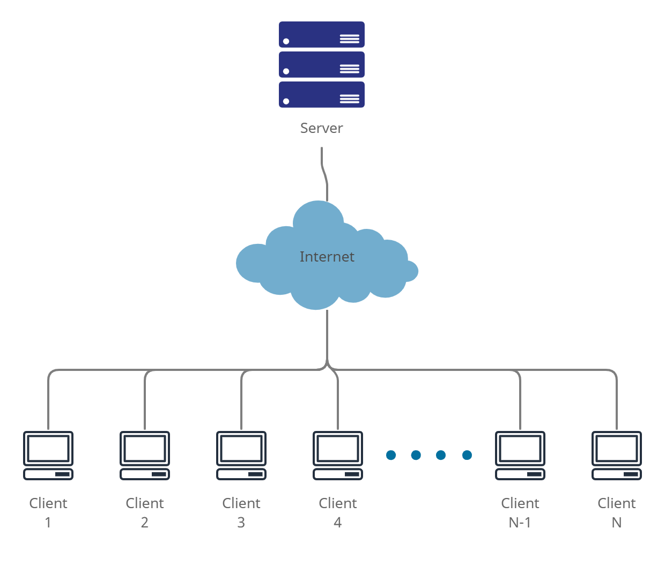

Figure 1: High Level System Architecture

*Figure shows high level system architecture (client-server architecture)*

### Image Authentication Module

This is the main module which will help in authentication and restoration of watermarked images. This module will also be reused in the video authentication module. This is due to the fact that video keyframes will also be considered as images and will be processed through this module to watermark keyframes of a video. This module has two sub modules which deal with authentication bits embedding whereas, the other module deals with recovery bits embedding.

#### Authentication Bits Embedding

Once an image has been divided into the required blocks according to our algorithm, the images will then be embedded with authentication bits. This process will be carried out by taking LSB of the divide blocks, taking hash value of those blocks and then storing that hash value inside the LSBs of some other image block.

#### Recovery Bits Embedding

This sub module will deal with embedding recovery bits into an image. This will be carried out by taking the mean of LSBs of a specific block and storing it in other blocks. Upon restoration, these bits will be extracted and will be placed back into the original block.

### Video Authentication Module

The video Authentication Model is mainly concerned with the authentication of video, in this module first all frames are extracted into an array of frames. Each frame is then embedded using the “Triple recovery information embedding” method. For fast authentication, we will divide the number of frames in a frame window by a random number and check that frame for any kind of tamper attack. This frame window will vary according to the type of video. For example, in a 30-fps video, a frame window will contain 30 frames and according to our algorithm, we will divide 30 by a random and then check the number of frames at specific point in a time of one second. Using this method, we will can have varying number of frames for 1 second of video and only these frames will be checked for any kind of tampering. This reduces the probability of missing any tampered frames because videos are usually tampered for more than 1 second and in our case, we are checking many frames in one second. This is better than checking every single frame for tampering but even still this will be very costly in terms of computations and to deal with the computation time required to perform this action, we will be using Lithops to create threads using multi-cloud serverless programming.

### Image Recovery Module

In this module the first thing the system does is to divide the image into blocks and extract the recovery bits embedded into the image using the algorithm mentioned above then. then it uses the authentication bits embedded in the image to test its authenticity. If image has been altered then it uses the recovery bits to permute the block of image to the whole image.

### Video Recovery Module

For video recovery, we are only dealing with spatial tampering which is tampering within the frame. Since we have already embedded each frame using “Triple recovery information embedding” method, we can easily recovery the tampered frame by using the image recovery module and applying it on the tampered frames. However, this process is not so simple because first we will have to identify the tampered frames in a frame window. These tampered frames will be delt separately and to recover original frames and these original frames will be replaced with the tampered frames which will give us the original video.

## Architectural Strategies

Following architectural strategies will be followed to implement this project.

### External Dependencies

Our system will be a web application so it will have a backend server along with the use of APIs. For the use of APIs, we will make use of REST APIs, which are implemented using NodeJS, to connect backend with our frontend. For now, we have not finalized which server we will be using; however, the python scripts of our system will be running on the server side. Since our system requires more resources to embed authentication and recovery bits, along with the process of authentication and restoration, therefore, it is important to select a suitable server. In our case, it could either be a local server or a web server with adequate resources.

### React, Node and Python

When it comes to image analysis and processing MATLAB is considered the best language, but the drawback of using MATLAB is that it is difficult with MATLAB when it comes to web-based projects. The second-best option in this regard is Python, it is easy to code and due to its famous libraries like OpenCV, scikit-image, etc. It is very easy and efficient to work with Python in the field of image processing. Another benefit of Python includes the ease of running scripts on web-based applications. Therefore, an image processing module for our system will be developed using Python. Moving on the front-end development of our project we will be using React JS, because React is a very popular and globally recognized JavaScript library. React is fast to use and easy to code as well due to the reusability of its components. Due to this reason, our backend development will be implemented using NodeJS.

### Concurrency

We will implement server concurrency so that it can handle multiple users at a time. However, this will also split the server resources and might turn into a drawback for our system which requires more computing power to process the multimedia uploaded by the users. Consequently, we will have to put a limit to the number of users that can access our services at once. This limit is for the initial stage of our system and can be later extended to handle more users at a time by extending server resources. Moving on to the implementation of our system, it will also require a certain degree of concurrency so that embedding, authentication and restoration processes can execute faster. This can be accomplished by using multi-threading and fine graining our problem into smaller independent parts that can be executed in parallel.

### Future Goals

Image and video tamper detection and content reconstruction systems are considered as one of the needs of the digital world. We came across various cases of image and video tampering which can cause defamation or false acquisitions, although we are developing a software to overcome these types of tampering cases but there is a chance of improvement as well. Our software can only detect tampering in those images and videos which are watermarked through our software because we are using active watermarking which means we place data in the media and authenticate using that data, so our future goal will be to implement passive watermarking [6] that is implemented using neural networks which will be able to detect tampering in image and video without placing any data inside the multimedia content. This ensures that the quality of multimedia content is not compromised by embedding more data into its LSB.

### User Interface Paradigms

The UI for our website has been designed in a way that is easy to navigate and simple to use. The eight golden rules for interface designing, by Ben Schneiderman, would be utilized which are part of the standards of human computer interaction.

### Database

We have decided not to implement a database for our system due to the working principle of our system, which embeds the required data inside the multimedia. This leaves no use of placing any data for the uploaded multimedia in a database. The embedded data is retrieved from the multimedia itself and its authentication bits are extracted and are compared to check for any tampering. In case of tampering, the recovery bits are then extracted from the multimedia and are used for restoration. In this whole process, there is no requirement for a database which would store user information.

## Use Cases

### Watermark Image

|  |  |  |  |  |
| --- | --- | --- | --- | --- |
| **Name** | | Watermark Image | | |
| **Actors** | | User | | |
| **Summary** | | The user shall upload an image which will then be watermarked by the system. | | |
| **Pre-Conditions** | | None | | |
| **Post-Conditions** | | The page reloads and the user can download the watermarked image from the same page. | | |
| **Special Requirements** | | Max image size is 50MB, dimensions of image should be n×n | | |
| **Basic Flow** | | | | |
| **Actor Action** | | | **System Response** | |
| 1 | User uploads an image. | | 2 | Place a watermark on the image. |
| **Alternative Flow** | | | | |
| 3 | The user uploads an image which exceeds the limit. | | 4-A | The system responds with an error message: *Image size too large.* |

### Watermark Video

|  |  |  |  |  |
| --- | --- | --- | --- | --- |
| **Name** | | Watermark video | | |
| **Actors** | | User | | |
| **Summary** | | The user shall upload a video which will then be watermarked by the system. | | |
| **Pre-Conditions** | | None | | |
| **Post-Conditions** | | The page reloads and the user can download the watermarked video from the same page. | | |
| **Special Requirements** | | Max image size is 50MB, dimensions of image should be n×n | | |
| **Basic Flow** | | | | |
| **Actor Action** | | | **System Response** | |
| 1 | User uploads a video. | | 2 | The system places a watermark on the video. |
| **Alternative Flow** | | | | |
| 3 | The user uploads a video which exceeds the limit. | | 4-A | The system responds with an error message: *Video size too large.* |

### Image Tamper Detection

|  |  |  |  |  |
| --- | --- | --- | --- | --- |
| **Name** | | Image Tamper Detection | | |
| **Actors** | | User | | |
| **Summary** | | The user shall upload a watermarked image which will then be processed by the system to detect any kind of tamper to the image | | |
| **Pre-Conditions** | | The image must be watermarked by the system. | | |
| **Post-Conditions** | | Users shall be able to view reports of tampering. | | |
| **Special Requirements** | | Image size must not be larger than 50MB. | | |
| **Basic Flow** | | | | |
| **Actor Action** | | | **System Response** | |
| 1 | User uploads an image. | | 2 | System processes the image and notifies the user if it is tampered. |
| **Alternative Flow** | | | | |
| 3 | Users upload an image which exceeds the limit. | | 4-A | The system responds with an error message: *Image size too large* |

### Video Tamper Detection

|  |  |  |  |  |
| --- | --- | --- | --- | --- |
| **Name** | | Video Tamper Detection | | |
| **Actors** | | User | | |
| **Summary** | | The user shall upload a watermarked video which will then be processed by the system to detect any kind of tamper to the video | | |
| **Pre-Conditions** | | The video must be watermarked by the system. | | |
| **Post-Conditions** | | Users shall be able to view reports of tampering. | | |
| **Special Requirements** | | Video size must not be larger than 50MB. | | |
| **Basic Flow** | | | | |
| **Actor Action** | | | **System Response** | |
| 1 | User uploads a video. | | 2 | System processes the video and notifies the user if it is tampered. |
| **Alternative Flow** | | | | |
| 3 | Users upload a video which exceeds the limit. | | 4-A | The system responds with an error message: *Video size too large* |

### Video Reconstruction

|  |  |  |  |  |
| --- | --- | --- | --- | --- |
| **Name** | | Video Reconstruction | | |
| **Actors** | | User | | |
| **Summary** | | The user shall upload a watermarked video which will then be processed by the system to reconstruct. | | |
| **Pre-Conditions** | | The video must be watermarked by the system. | | |
| **Post-Conditions** | | Users shall be able to download recovered video. | | |
| **Special Requirements** | | Video size must not be larger than 50MB. | | |
| **Basic Flow** | | | | |
| **Actor Action** | | | **System Response** | |
| 1 | User uploads a video. | | 2 | System processes the tampered video and reconstructs the original video for the user to download. |
| **Alternative Flow** | | | | |
| 3 | Users upload a video which exceeds the limit. | | 4-A | The system responds with an error message: *Video size too large* |

### Image Reconstruction

|  |  |  |  |  |
| --- | --- | --- | --- | --- |
| **Name** | | Image Reconstruction | | |
| **Actors** | | User | | |
| **Summary** | | The user shall upload a watermarked image which will then be processed by the system to reconstruct. | | |
| **Pre-Conditions** | | The image must be watermarked by the system. | | |
| **Post-Conditions** | | Users shall be able to download recovered images. | | |
| **Special Requirements** | | Image size must not be larger than 50MB. | | |
| **Basic Flow** | | | | |
| **Actor Action** | | | **System Response** | |
| 1 | User uploads an image. | | 2 | System processes the tampered image and reconstructs the original image for the user to download. |
| **Alternative Flow** | | | | |
| 3 | User uploads an image which exceeds the limit. | | 4-A | The system responds with an error message: *Image size too large* |

## GUI

This section provides a prototype GUI of the project.

### Add Watermark

#### Interface Before Image is Watermarked

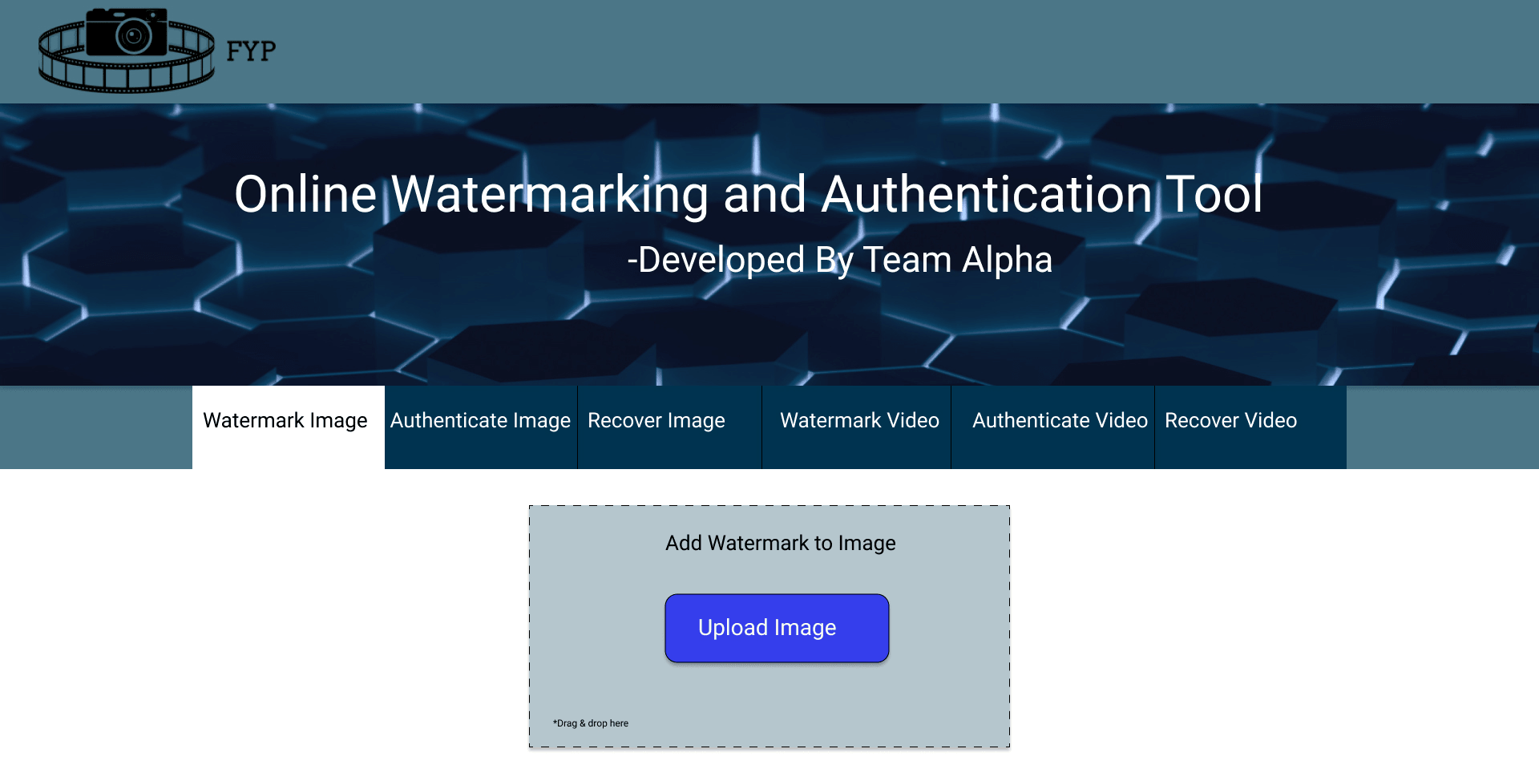

Figure 2: Interface Before Image is Watermarked

*Figure shows the user interface for before watermarking an image*

#### Interface After Image is Watermarked

Figure 3: Interface After Image is Watermarked

*Figure shows user interface after an image has been watermarked*

### Upload Image

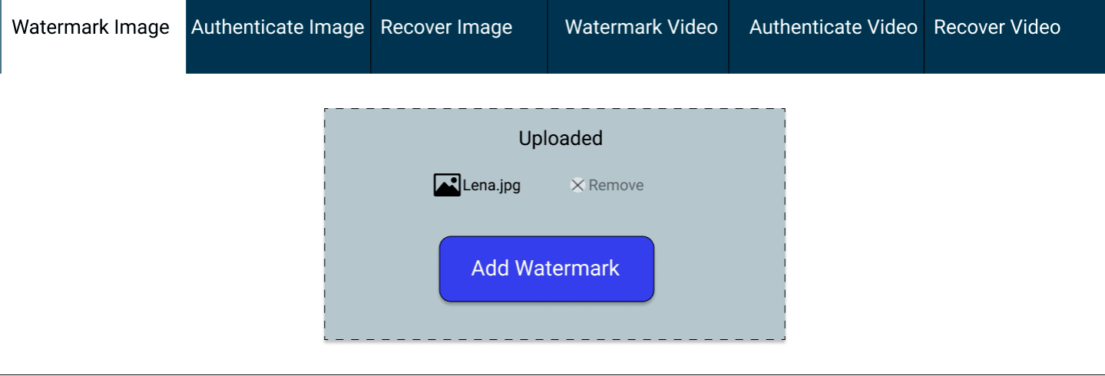

Figure 4: Upload Image

*Figure shows the user interface for uploading an image*

### Upload Video

#### Interface Before Video is Uploaded

Figure 5: Interface Before Video is Uploaded

*Figure shows user interface before uploading video*

#### Interface After Video is Uploaded

Figure 6: Interface After Video is Uploaded

*Figure shows interface after video is uploaded*

### Video Authentication

Figure 7: Video Authentication

*Figure shows interface after video is uploaded*

### Video Restoration

Figure 8: Video Restoration

*Figure shows interface after video is restored*

## System Requirements

The system will require the following features to process as required:

* Stable internet connection so that the user can successfully upload files to server and download the required files from the website.
* UpToDate web browser which supports the required UI libraries.
* NodeJS runtime environment.
* Python
* Material UI.
* A good webserver to handle all the server-side processing load.

## Design Considerations

This section describes many of the issues which need to be addressed or resolved before attempting to devise a complete design solution. These issues include assumptions and dependencies along with general constraints of the system.

### Assumptions

We assume the following scenarios when a user is interacting with our system:

* On multimedia tamper detection or restoration requests, it is assumed that the user has already watermarked that multimedia through our system.
* Uploaded media is within the upload limit defined by the server.
* Multimedia uploaded for watermarking is original i.e., it has not been tampered before the watermarking process.

### Dependencies

Our system has the following dependencies:

* Since all the data is embedded in the digital multimedia, there is no need for a database to store any kind of information regarding the file user uploads to the server.
* Multimedia tamper detection is dependent on the fact that it should be watermarked through our system beforehand.
* Similarly, multimedia recovery also depends whether it was watermarked by our system or not.
* Multimedia recovery has an upper limit depending on the type of multimedia.
  + For image, it is approximately 75%.
  + For video, approximately 67.5% of tampered video can be recovered.
* Minimum dimension of image is 512 ✕ 512.
* Multimedia processing may require a lot of resources, therefore, a good server with high end GPU would be needed to run scripts on backend.

## Development Methods

This section describes the methods that were studied and the methods that will be used to implement this project. Moreover, this section also includes the methods that were considered but were not used due to reasons mentioned in the later subsections.

### Algorithms

Various algorithms were researched and taken into consideration [1-3] before finalizing on one algorithm to implement. The mentioned algorithm uses triple recovery for effective authentication and recovery. Moreover, there was one algorithm which also generated good results while being efficient therefore, we will compare the results of the two methods and then decide which one shall be extended to video authentication and restoration .

#### Image Authentication and Restoration

The algorithm used to authenticate the image and reconstruct it is from [1]. Let's first talk about the authentication of the image. The algorithm does it in such a way that it first divides the image into 16 equal blocks then makes a lookup table to select the partner block in each region. Then it divides the 16 main blocks into 4x4 blocks and takes the average of the bits of each image block. Then these average bits of the partner blocks are combined and hashed to generate keys. Then each partner block is divided into 16x16 blocks and then these divided blocks are further divided into 8x8 blocks then the key generated is inserted into the first and second LSB. Then the whole image is combined together and used wherever the user wants. Now to authenticate the algorithm first extract the authentication bits from the image by dividing it the same as above as computing the has again if the computed hash and extracted hash are same then image has not been tampered else it has been tampered. Similarly, the recovery bits are also added into the image to watermark it. Then, on recovery the system first checks whether the image has been tampered or not, if it has been tampered then it divides the image into the same block as above and then it combines the recovery bits extracted from the image and permutates recovery bits with the help of key. Then it first recovers 4x4 blocks and then it recovers 16x16 blocks then it replaces the recovery block with the tamped block and combines the whole image.

#### Video Authentication and Restoration

This module makes extensive use of image modules for authentication and restoration. Video has a large number of frames that can be treated the same way as images. During the authentication, number of frames in a frame window will be divided by a single random number to generate a number which will then be used as a reference to extract the number of frames in one second. For example, if we get 5 as a result of dividing fps with a random number, we will extract 5 frames from random positions in a frame window. For video restoration, we will first identify the tampered frames from the frame window and will then execute image recovery modules on the tampered frames.

#### Pixel-wise Authentication and Recovery

This method is the latest research in this field, which made use of pixel wise processing unlike other methods that relied on block-wise image authentication and restoration. This method is more efficient in terms of tamper detection and processes on a smaller area (pixels) as compared to block wise image authentication which processes the whole image block even if a single pixel was tampered. However, this method could not yield as great a restoration percentage as compared to the triple recovery method [1, 2]. Which is why we will thoroughly compare the results of both methods which would include their PSNR, authentication percentage and recovery percentage.

### Development Methodology Used

Upon looking into various software development models [7], we decided to follow the scrum methodology, which is based on iterative and incremental process, for the implementation of this project. According to the mentioned timeline of modules, we have divided the project in various phases which will be implemented in a series of sprints and will later undergo through a process of various test cases [5]. Using this method, we will be able to develop and test the system in small pieces and then at the end of the whole process, it will be integrated at server end and the finished web application will be deployed on a selected server.

## Class diagram

This section shows the class diagram of the system.

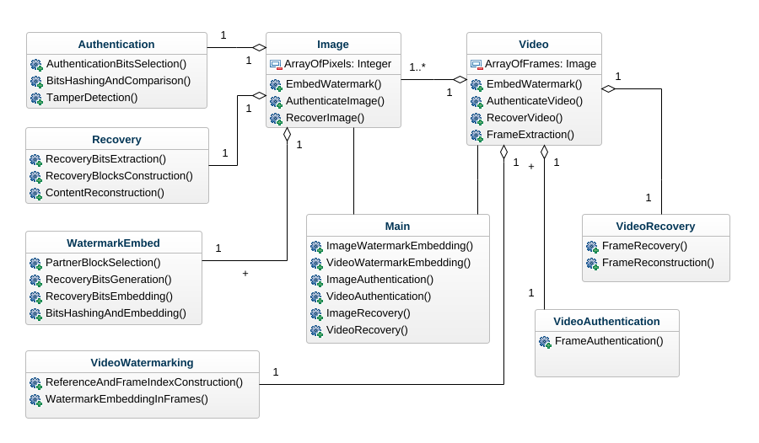

Figure 9: Class Diagram

*Figure shows class diagram of the system*

## Sequence diagram

Following are the sequence diagrams for the system.

### Image Authentication

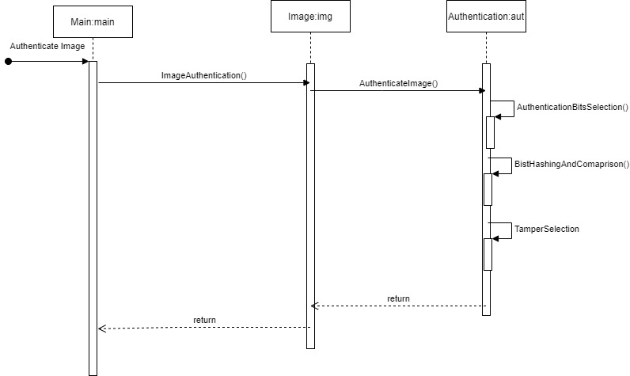

Figure 10: Image Authentication Sequence Diagram

*Figure shows sequence diagram for image authentication*

### Video Authentication

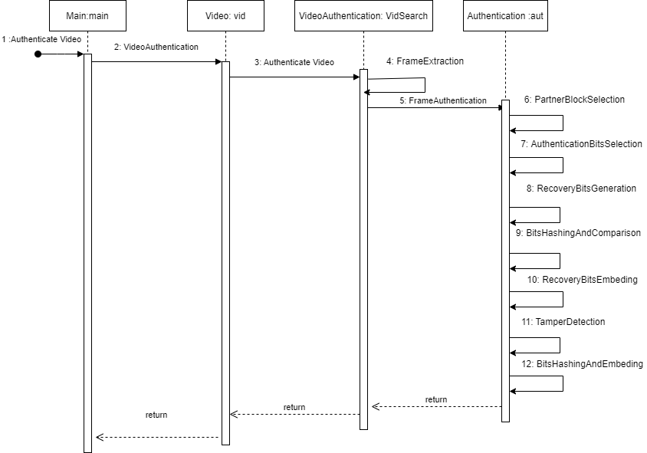

Figure 11: Video Authentication Sequence Diagram

*Figure shows sequence diagram for video authentication*

### Image Restoration

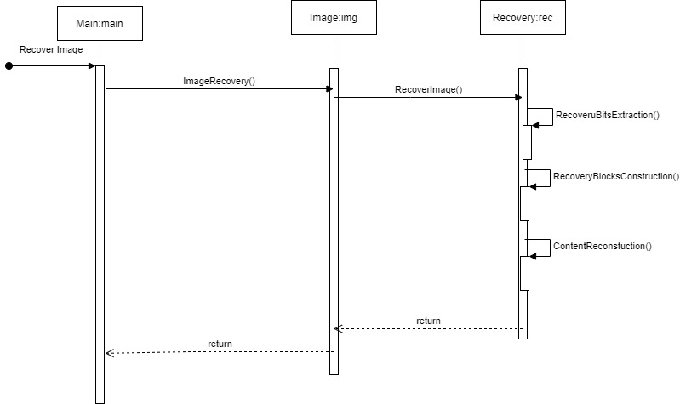

Figure 12: Image Restoration Sequence Diagram

*Figure shows sequence diagram for image restoration*

### Video Restoration

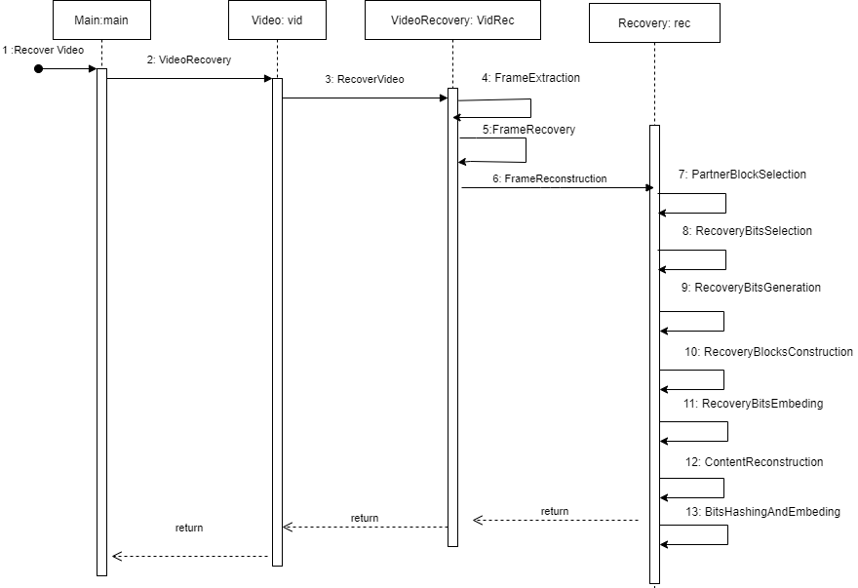

Figure 13: Video Restoration Sequence Diagram

*Figure shows sequence diagram for video restoration*

### Image Watermarking

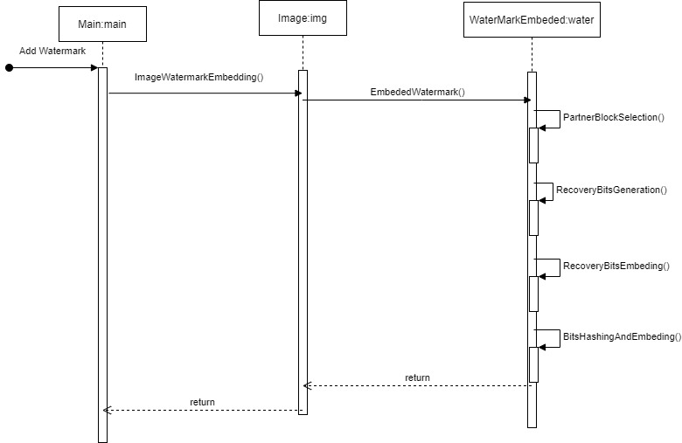

Figure 14: Image Watermarking Sequence Diagram

*Figure shows sequence diagram for image watermarking*

### Video Watermarking

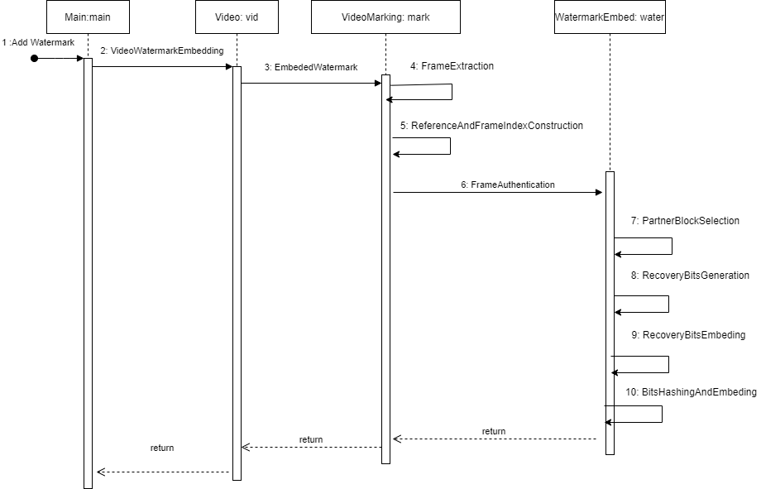

Figure 15: Video Watermarking Sequence Diagram

*Figure shows sequence diagram for video watermarking*

## Policies and Tactics

### Tools to be Used

Visual studio code will be used for both frontend and backend development. Here the backend development means the multimedia processing scripts that will be running on the server side. We will use NodeJS for APIs to communicate with the server so that it can execute user requests. Python scripts will be tested on Google Collab because it has GPU sources integrated.

### Policy for User Interface

A basic interface has been selected that shows the user all available functionalities of our system in one place. The user can choose any of the functionalities with ease by just clicking once.

### Coding Guidelines

The system will be implemented while following the coding standards, along with a well-documented code. All the coding standards will be followed to increase readability of the system code.

### Plans for using Latest Technologies

We plan to use the latest technologies such as ReactJS for frontend and NodeJS for API calls. Whereas we will be using the latest version of python to create multimedia processing scripts.

### Policy for Software Testing

Along with a full test of the system, we will do white box testing and black box testing. For white box testing, we will test the system using control flow and data flow testing. For black box testing, we will do unit testing and integration testing. In case there is an issue with testing we will also do a bit of regression testing.

### Accessing the System

Since our system would be hosted on a server, it will be accessible through a URL. This will allow any computer (even the ones with lower specifications) to access the system and use its functionalities easily without any burden on their computer.

### Policy for System Maintenance

We will have to make regular maintenance checks depending on the amount of user requests at a given time. Since our system relies on computing power, if the server is busy handling one user, the other users would end up in a waiting queue. Therefore, the system would require regular maintenance checks to see if it requires more resources or not.

# Implementation and Test Cases

The project's system overview, which includes the number of functionalities in the project as well as the design, which explains how the system will be built, and finally the system's working, which explains how the user will use the system as well as what choices the system will give, what functions the system will perform, and in what order the functions are performed, are provided below.

## Watermarking

Watermarking is the main feature of our system in which the media is watermarked the system by embedding the authentication bits, which are created by inputting the image's bits into the MD5 hash function, and its hash value is the bits embedded into the media's LSB. The embedded bits are used by the system's tamper detection. [1]

### Hash Value Generation for Authentication Bits

We will make a few changes to the normal authentication bits embedding process for triple recovery method. Firstly, we will use a python library called Blake2b which generates dynamic length hash which are unique at different lengths. For example, in our case, we do not need a full 128-bit hash, instead we need 104 bits hash. The remaining 24 bits will be used to store image size which is a multiple of 64 along with different variants of lookup table and block number. One way to get 104-bit hash was to first generate 128-bit hash value and truncate the extra bits, which would be an extremely bad way to get dynamic hash value. This is where the usage of Blake2b comes in which gives us dynamic 104-bit hash value without any truncation. This may raise concerns regarding hash collision which is why we studied a research paper for this method that shows us chances for hash collision and also tells us about how Blake2b generates secure and dynamic length hash values. [13]

### Multiple Variants of Lookup Table

Initially, a concern was raised regarding the security of lookup table according to which, a user may be able to exploit block placing in lookup table and compromise the efficiency for image restoration. This would result in our system failing to recover an image which was tampered less than the limit that is 75%. To solve this issue, we generated multiple lookup table which would not affect image restoration efficiency and would also introduce more secure watermarking. When a user will watermark an image through our system, they will need to provide a secure password which will be used to generate a value to select a lookup table variant. The user will need this password if they wish to authenticate or recover a tampered image. This will also prove as an ownership of that specific media because only the person with the right password will be able to recovery the original image from the tampered image. This also one of the reasons, we have reduced 128-bit hash size to 104-bit because we will be using few of the bits to store lookup table variant number which will be extracted and used during authentication and recovery process.

### Implementation of Image Division

Our initial work began with dividing the image into small blocks according to our implementation method. For image division into 4 x 2 or 2 x 4 blocks, NumPy library was used. However, it was not able to properly reshape the image blocks into the required form. This means that it successfully reshaped according to the required size of block but it was not able to properly add the correct data into those blocks. Upon further research on working of NumPy reshape, we came across an article that explained how image data is converted into another dimension before being divided into smaller parts. [9]

## Tamper Detection and Recovery

The algorithm used to authenticate the image and reconstruct it is from [1, 2].

### Triple Recovery Method

Let's first talk about the authentication of the image. The algorithm does it in such a way that it first divides the image into 16 equal blocks then makes a lookup table to select the partner block in each region. Then it divides the 16 main blocks into 4x4 blocks and takes the average of the bits of each image block. Then these average bits of the partner blocks are combined and hashed to generate keys. Then each partner block is divided into 16x16 blocks and then these divided blocks are further divided into 8x8 blocks then the key generated is inserted into the first and second LSB. Then the whole image is combined together and used wherever the user wants. Now to authenticate the algorithm first extract the authentication bits from the image by dividing it the same as above as computing the has again if the computed hash and extracted hash are same then image has not been tampered else it has been tampered. Similarly, the recovery bits are also added into the image to watermark it. Then, on recovery the system first checks whether the image has been tampered or not, if it has been tampered then it divides the image into the same block as above and then it combines the recovery bits extracted from the image and permutates recovery bits with the help of key. Then it first recovers 4x4 blocks and then it recovers 16x16 blocks then it replaces the recovery block with the tamped block and combines the whole image.

### Pixel-wise Authentication and Recovery

This method is the latest research in this field, which made use of pixel wise processing unlike other methods that relied on block-wise image authentication and restoration. This method is more efficient in terms of tamper detection and processes on a smaller area (pixels) as compared to block wise image authentication which processes the whole image block even if a single pixel was tampered. In this method, we first determine which orientation the image should be divided in (2 x 4 or 4 x 2 orientation). This is carried out by dividing the image into either of the two block types and comparing their PSNR values. The one with better PSNR value is selected for authentication and recovery bits embedding process. This process is similar to the one mentioned before but the plus point is that this method operates on pixel level instead of this block level. This can ensure image quality and due to this reason, we are considering this method even though it has lesser restoration rate (50% max).

## Video Authentication and Restoration

This module makes extensive use of image modules for authentication and restoration. Video has a large number of frames that can be treated the same way as images. Processing on a large number of frames for a video can be computationally very expensive and it will also depend on the type of video, for example, computation time for a 30fps video will be different from a 60fps video. This is why we have optimized our way of checking for tampering in a video, by processing the video second by second and then checking any kind of tampering attack on specific frames in that frame window. This will reduce our computation time a lot as compared to processing every single frame of a video. Moreover, due to using randomization of frame selection in a frame window, we are even reducing the probability of missing any tampered frame. The backing reason for this assumption is that the tamper attacks on videos are not usually one frame only, but on many frames.

### Video Authentication

As mentioned before, instead of checking all frames in the whole video, we will introduce randomization in the process of frame monitoring. The video will be processed in a series of frame windows. Each frame window can have different frames according to the type of video. A 30fps video can have 30 frames in 1 frame window, a 60fps video can have 60 frames in 1 frame window. The process of random frame selection includes dividing the total number of frames in a frame window by a random positive number between one and ten. The number thus obtained from this division will the be used as a reference to check the required number of frames randomly in a frame window.

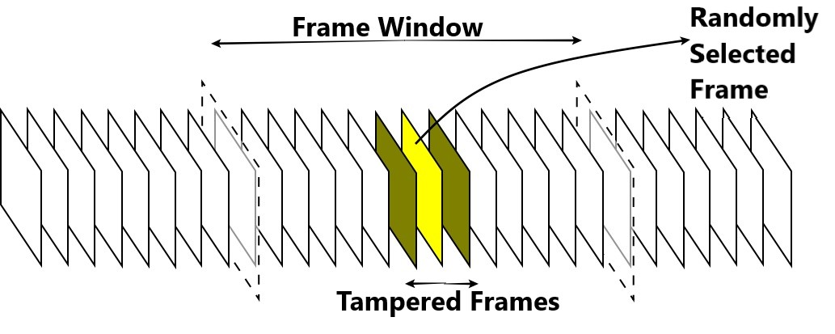

Figure 16: Random Frame Selection

*Figure shows the random frame selection process from window of frames*

The image authentication module will be used to check the selected random frames for any kind of tampering. In case, tampering is detected from any one of the selected frames from a frame window. We will process all frames in that specific frame window.

### Video Restoration

The tampered frames will be extracted and stored separately along with window number and index of frame in that window. Once the whole video has been processed, we will recover the tampered frames by using the image recovery module on each frame. The recovered frames will then be replaced with the tampered frames using window number and frame index.

## Test Case Design and Description

### Image Watermark

|  |  |  |  |  |  |
| --- | --- | --- | --- | --- | --- |
| **Image Watermark Embedding** | | | | | |
| **Embedding** | | | | | |
| Test Case ID: | | *4.4.1* | QA Test Engineer: | | *Usama Aslam* |
| Test case Version: | | *1.0* | Reviewed By: | | *Arbab Hamad* |
| Test Date: | | *05-18-2022* | Use Case Reference(s): | | *Image watermark* |
| Revision History: | | *None* | | | |
| Objective | | *Watermark the image* | | | |
| Product/Ver/Module: | | *Watermarking module* | | | |
| Environment: | | *Software: Any modern Browser*  *Hardware: PC* | | | |
| Assumptions: | | *Image should be uploaded* | | | |
| Pre-Requisite: | | *System should be working properly.* | | | |
| Step No. | Execution description | | | Procedure result | |
| 1 | *User opens the web application.* | | | *Main page opened.* | |
| 2 | *User uploaded the image and entered secret key.* | | | *Image uploaded.* | |
| 3 | *User select watermark embedding option.* | | | *Image is watermarked. User is given the option to download the image* | |
| Comments:  Application works properly | | | | | |
| *Passed* *Failed* *Not Executed* | | | | | |

### Image Watermark (Alternate-4A)

|  |  |  |  |  |  |
| --- | --- | --- | --- | --- | --- |
| **Image Watermark Embedding** | | | | | |
| **Embedding** | | | | | |
| Test Case ID: | | *4.4.2* | QA Test Engineer: | | *Usama Aslam* |
| Test case Version: | | *1.0* | Reviewed By: | | *Arbab Hamad* |
| Test Date: | | *05-18-2022* | Use Case Reference(s): | | *Image watermark* |
| Revision History: | | *None* | | | |
| Objective | | *Watermark the image* | | | |
| Product/Ver/Module: | | *Watermarking module* | | | |
| Environment: | | *Software: Any modern Browser*  *Hardware: PC* | | | |
| Assumptions: | | *Image should be uploaded* | | | |
| Pre-Requisite: | | *System should be working properly.* | | | |
| Step No. | Execution description | | | Procedure result | |
| 1 | *User opens the web application.* | | | *Main page opened.* | |
| 2 | *User uploaded the image with wrong dimensions and entered secret key.* | | | *Image uploaded.* | |
| 3 | *User select watermark embedding option.* | | | *Image is not watermarked, and error message displayed.* | |
| Comments:  Application works properly | | | | | |
| *Passed Failed Not Executed* | | | | | |

### Video Watermark

|  |  |  |  |  |  |
| --- | --- | --- | --- | --- | --- |
| **Video Watermark Embedding** | | | | | |
| **Embedding** | | | | | |
| Test Case ID: | | *4.4.3* | QA Test Engineer: | | *Usama Aslam* |
| Test case Version: | | *1.0* | Reviewed By: | | *Arbab Hamad* |
| Test Date: | | *05-18-2022* | Use Case Reference(s): | | *Video watermark* |
| Revision History: | | *None* | | | |
| Objective | | *Watermark the video* | | | |
| Product/Ver/Module: | | *Watermarking module* | | | |
| Environment: | | *Software: Any modern Browser*  *Hardware: PC* | | | |
| Assumptions: | | *Video should be uploaded* | | | |
| Pre-Requisite: | | *System should be working properly.* | | | |
| Step No. | Execution description | | | Procedure result | |
| 1 | *User opens the web application.* | | | *Main page opened.* | |
| 2 | *User uploaded the video and entered secret key.* | | | *Video uploaded.* | |
| 3 | *User select watermark embedding option.* | | | *Video is watermarked. The user is given the option to download the image.* | |
| Comments:  Application works properly | | | | | |
| *Passed Failed Not Executed* | | | | | |

### Video Watermark (Alternate-4A)

|  |  |  |  |  |  |
| --- | --- | --- | --- | --- | --- |
| **Video Watermark Embedding** | | | | | |
| **Embedding** | | | | | |
| Test Case ID: | | *4.4.4* | QA Test Engineer: | | *Usama Aslam* |
| Test case Version: | | *1.0* | Reviewed By: | | *Arbab Hamad* |
| Test Date: | | *05-18-2022* | Use Case Reference(s): | | *Video watermark* |
| Revision History: | | *None* | | | |
| Objective | | *Watermark the video* | | | |
| Product/Ver/Module: | | *Watermarking module* | | | |
| Environment: | | *Software: Any modern Browser*  *Hardware: PC* | | | |
| Assumptions: | | *Video should be uploaded* | | | |
| Pre-Requisite: | | *System should be working properly.* | | | |
| Step No. | Execution description | | | Procedure result | |
| 1 | *User opens the web application.* | | | *Main page opened.* | |
| 2 | *User uploaded the video with wrong dimensions and enters secret key.* | | | *Video uploaded.* | |
| 3 | *User selects watermark embedding option.* | | | *Video is not watermarked, and error message displayed.* | |
| Comments:  Application works properly | | | | | |
| *Passed Failed Not Executed* | | | | | |

### Image Tamper Detection

|  |  |  |  |  |  |
| --- | --- | --- | --- | --- | --- |
| **Image Tamper Detection** | | | | | |
| **Authentication** | | | | | |
| Test Case ID: | | *4.4.5* | QA Test Engineer: | | *Usama Aslam* |
| Test case Version: | | *1.0* | Reviewed By: | | *Arbab Hamad* |
| Test Date: | | *05-18-2022* | Use Case Reference(s): | | *Image tamper detection* |
| Revision History: | | *None* | | | |
| Objective | | *Authenticate the watermarked image* | | | |
| Product/Ver/Module: | | *Authentication module* | | | |
| Environment: | | *Software: Any modern Browser*  *Hardware: PC* | | | |
| Assumptions: | | *Watermarked image should be uploaded* | | | |
| Pre-Requisite: | | *System should be working properly.* | | | |
| Step No. | Execution description | | | Procedure result | |
| 1 | *User opens the web application.* | | | *Main page opened.* | |
| 2 | *User uploaded the watermarked image and entered secret key.* | | | *Image uploaded.* | |
| 3 | *User selects tamper detection option.* | | | *Tampering report is shown.* | |
| Comments:  Application works properly | | | | | |
| *Passed Failed Not Executed* | | | | | |

### Image Tamper Detection (Alternate-4A)

|  |  |  |  |  |  |
| --- | --- | --- | --- | --- | --- |
| **Image Tamper Detection** | | | | | |
| **Authentication** | | | | | |
| Test Case ID: | | *4.4.6* | QA Test Engineer: | | *Usama Aslam* |
| Test case Version: | | *1.0* | Reviewed By: | | *Arbab Hamad* |
| Test Date: | | *05-18-2022* | Use Case Reference(s): | | *Image tamper detection* |
| Revision History: | | *None* | | | |
| Objective | | *Authenticate the watermarked image* | | | |
| Product/Ver/Module: | | *Authentication module* | | | |
| Environment: | | *Software: Any modern Browser*  *Hardware: PC* | | | |
| Assumptions: | | *Watermarked image should be uploaded* | | | |
| Pre-Requisite: | | *System should be working properly.* | | | |
| Step No. | Execution description | | | Procedure result | |
| 1 | *User opens the web application.* | | | *Main page opened.* | |
| 2 | *User uploaded the watermarked image and entered incorrect secret key.* | | | *Image uploaded.* | |
| 3 | *User selects tamper detection option.* | | | *Error message displayed with option to re-enter the key.* | |
| Comments:  Application works properly | | | | | |
| *Passed Failed Not Executed* | | | | | |

### Image Tamper Detection (Alternate-4B)

|  |  |  |  |  |  |
| --- | --- | --- | --- | --- | --- |
| **Image Tamper Detection (Alterante-4B)** | | | | | |
| **Authentication** | | | | | |
| Test Case ID: | | *4.4.7* | QA Test Engineer: | | *Usama Aslam* |
| Test case Version: | | *1.0* | Reviewed By: | | *Arbab Hamad* |
| Test Date: | | *05-18-2022* | Use Case Reference(s): | | *Image tamper detection* |
| Revision History: | | *None* | | | |
| Objective | | *Authenticate the watermarked image* | | | |
| Product/Ver/Module: | | *Authentication module* | | | |
| Environment: | | *Software: Any modern Browser*  *Hardware: PC* | | | |
| Assumptions: | | *Watermarked image should be uploaded* | | | |
| Pre-Requisite: | | *System should be working properly.* | | | |
| Step No. | Execution description | | | Procedure result | |
| 1 | *User opens the web application.* | | | *Main page opened.* | |
| 2 | *User uploaded the image which is not watermarked and entered secret key.* | | | *Image uploaded.* | |
| 3 | *Users select tamper detection option.* | | | *Error message displayed.* | |
| Comments:  Application works properly | | | | | |
| *Passed Failed Not Executed* | | | | | |

### Video Tamper Detection

|  |  |  |  |  |  |
| --- | --- | --- | --- | --- | --- |
| **Video Tamper Detection** | | | | | |
| **Authentication** | | | | | |
| Test Case ID: | | *4.4.8* | QA Test Engineer: | | *Usama Aslam* |
| Test case Version: | | *1.0* | Reviewed By: | | *Arbab Hamad* |
| Test Date: | | *05-18-2022* | Use Case Reference(s): | | *Video tamper detection* |
| Revision History: | | *None* | | | |
| Objective | | *Authenticate the watermarked Video* | | | |
| Product/Ver/Module: | | *Authentication module* | | | |
| Environment: | | *Software: Any modern Browser*  *Hardware: PC* | | | |
| Assumptions: | | *Watermarked video should be uploaded* | | | |
| Pre-Requisite: | | *System should be working properly.* | | | |
| Step No. | Execution description | | | Procedure result | |
| 1 | *User opens the web application.* | | | *Main page opened.* | |
| 2 | *User uploaded the watermarked video and entered secret key.* | | | *Video uploaded.* | |
| 3 | *User selects tamper detection option.* | | | *Tampering report is shown.* | |
| Comments:  Application works properly | | | | | |
| *Passed Failed Not Executed* | | | | | |

### Video Tamper Detection (Alternate-4A)

|  |  |  |  |  |  |
| --- | --- | --- | --- | --- | --- |
| **Video Tamper Detection** | | | | | |
| **Authentication** | | | | | |
| Test Case ID: | | *4.4.9* | QA Test Engineer: | | *Aashar Naseem* |
| Test case Version: | | *1.0* | Reviewed By: | | *Hunzlah Maiik* |
| Test Date: | | *05-18-2022* | Use Case Reference(s): | | *Video tamper detection* |
| Revision History: | | *None* | | | |
| Objective | | *Authenticate the watermarked Video* | | | |
| Product/Ver/Module: | | *Authentication module* | | | |
| Environment: | | *Software: Any modern Browser*  *Hardware: PC* | | | |
| Assumptions: | | *Watermarked video should be uploaded* | | | |
| Pre-Requisite: | | *System should be working properly.* | | | |
| Step No. | Execution description | | | Procedure result | |
| 1 | *User opens the web application.* | | | *Main page opened.* | |
| 2 | *User uploaded the watermarked video and entered wrong secret key.* | | | *Video uploaded.* | |
| 3 | *User selects tamper detection option.* | | | *Error message displayed with option to re-enter the key.* | |
| Comments:  Application works properly | | | | | |
| *Passed Failed Not Executed* | | | | | |

### Video Tamper Detection (Alternate-4B)

|  |  |  |  |  |  |
| --- | --- | --- | --- | --- | --- |
| **Video Tamper Detection** | | | | | |
| **Authentication** | | | | | |
| Test Case ID: | | *4.4.10* | QA Test Engineer: | | *Aashar Naseem* |
| Test case Version: | | *1.0* | Reviewed By: | | *Hunzlah Malik* |
| Test Date: | | *05-18-2022* | Use Case Reference(s): | | *Video tamper detection* |
| Revision History: | | *None* | | | |
| Objective | | *Authenticate the watermarked Video* | | | |
| Product/Ver/Module: | | *Authentication module* | | | |
| Environment: | | *Software: Any modern Browser*  *Hardware: PC* | | | |
| Assumptions: | | *Watermarked video should be uploaded* | | | |
| Pre-Requisite: | | *System should be working properly.* | | | |
| Step No. | Execution description | | | Procedure result | |
| 1 | *User opens the web application.* | | | *Main page opened.* | |
| 2 | *User uploaded the video which is not watermarked and entered secret key.* | | | *Video uploaded.* | |
| 3 | *User selects tamper detection option.* | | | *Error message displayed.* | |
| Comments:  Application works properly | | | | | |
| *Passed Failed Not Executed* | | | | | |

### Image Recovery

|  |  |  |  |  |  |
| --- | --- | --- | --- | --- | --- |
| **Image Content Recovery** | | | | | |
| **Recovery** | | | | | |
| Test Case ID: | | *4.4.11* | QA Test Engineer: | | *Usama Aslam* |
| Test case Version: | | *1.0* | Reviewed By: | | *Arbab Hamad* |
| Test Date: | | *05-18-2022* | Use Case Reference(s): | | *Image Content Recovery* |
| Revision History: | | *None* | | | |
| Objective | | *Recover the tampered image* | | | |
| Product/Ver/Module: | | *Recovery module* | | | |
| Environment: | | *Software: Any modern Browser*  *Hardware: PC* | | | |
| Assumptions: | | *Watermarked image should be uploaded* | | | |
| Pre-Requisite: | | *System should be working properly.* | | | |
| Step No. | Execution description | | | Procedure result | |
| 1 | *Users open the web application.* | | | *Main page opened.* | |
| 2 | *User uploaded the image which is watermarked and tampered and entered secret key.* | | | *Image uploaded.* | |
| 3 | *Users select image recovery option.* | | | *Image content is recovered and download option displayed.* | |
| Comments:  Application works properly | | | | | |
| *Passed Failed Not Executed* | | | | | |

### Image Recovery (Alternate-4A)

|  |  |  |  |  |  |
| --- | --- | --- | --- | --- | --- |
| **Image Content Recovery** | | | | | |
| **Recovery** | | | | | |
| Test Case ID: | | *4.4.12* | QA Test Engineer: | | *Usama Aslam* |
| Test case Version: | | *1.0* | Reviewed By: | | *Arbab Hamad* |
| Test Date: | | *05-18-2022* | Use Case Reference(s): | | *Image Content Recovery* |
| Revision History: | | *None* | | | |
| Objective | | *Recover the tampered image* | | | |
| Product/Ver/Module: | | *Recovery module* | | | |
| Environment: | | *Software: Any modern Browser*  *Hardware: PC* | | | |
| Assumptions: | | *Watermarked image should be uploaded* | | | |
| Pre-Requisite: | | *System should be working properly.* | | | |
| Step No. | Execution description | | | Procedure result | |
| 1 | *User opens the web application.* | | | *Main page opened.* | |
| 2 | *User uploaded the image which is not watermarked and entered secret key.* | | | *Image uploaded.* | |
| 3 | *User selects image recovery option.* | | | *Error message displayed.* | |
| Comments:  Application works properly | | | | | |
| *Passed Failed Not Executed* | | | | | |

### Image Recovery (Alternate-4B)

|  |  |  |  |  |  |
| --- | --- | --- | --- | --- | --- |
| **Image Content Recovery** | | | | | |
| **Recovery** | | | | | |
| Test Case ID: | | *4.4.13* | QA Test Engineer: | | *Usama Aslam* |
| Test case Version: | | *1.0* | Reviewed By: | | *Arbab Hamad* |
| Test Date: | | *05-18-2022* | Use Case Reference(s): | | *Image Content Recovery* |
| Revision History: | | *None* | | | |
| Objective | | *Recover the tampered image* | | | |
| Product/Ver/Module: | | *Recovery module* | | | |
| Environment: | | *Software: Any modern Browser*  *Hardware: PC* | | | |
| Assumptions: | | *Watermarked image should be uploaded* | | | |
| Pre-Requisite: | | *System should be working properly.* | | | |
| Step No. | Execution description | | | Procedure result | |
| 1 | *User opens the web application.* | | | *Main page opened.* | |
| 2 | *User uploaded the image, which is watermarked and too much tampered, and entered secret key.* | | | *Image uploaded.* | |
| 3 | *User selects image recovery option.* | | | *Image not recovered.* | |
| Comments:  Application works properly | | | | | |
| *Passed Failed Not Executed* | | | | | |

### Image Recovery (Alternate-4C)

|  |  |  |  |  |  |
| --- | --- | --- | --- | --- | --- |
| **Image Content Recovery** | | | | | |
| **Recovery** | | | | | |
| Test Case ID: | | *4.4.14* | QA Test Engineer: | | *Usama Aslam* |
| Test case Version: | | *1.0* | Reviewed By: | | *Arbab Hamad* |
| Test Date: | | *05-18-2022* | Use Case Reference(s): | | *Image Content Recovery* |
| Revision History: | | *None* | | | |
| Objective | | *Recover the tampered image* | | | |
| Product/Ver/Module: | | *Recovery module* | | | |
| Environment: | | *Software: Any modern Browser*  *Hardware: PC* | | | |
| Assumptions: | | *Watermarked image should be uploaded* | | | |
| Pre-Requisite: | | *System should be working properly.* | | | |
| Step No. | Execution description | | | Procedure result | |
| 1 | *User opens the web application.* | | | *Main page opened.* | |
| 2 | *User uploaded the image which is watermarked and tampered and entered wrong secret key.* | | | *Image uploaded.* | |
| 3 | *User selects image recovery option.* | | | *Error message displayed with option to re-enter key.* | |
| Comments:  Application works properly | | | | | |
| *Passed Failed Not Executed* | | | | | |

### Video Recovery

|  |  |  |  |  |  |
| --- | --- | --- | --- | --- | --- |
| **Video Content Recovery** | | | | | |
| **Recovery** | | | | | |
| Test Case ID: | | *4.4.15* | QA Test Engineer: | | *Usama Aslam* |
| Test case Version: | | *1.0* | Reviewed By: | | *Arbab Hamad* |
| Test Date: | | *05-18-2022* | Use Case Reference(s): | | *Video Content Recovery* |
| Revision History: | | *None* | | | |
| Objective | | *Recover the tampered video* | | | |
| Product/Ver/Module: | | *Recovery module* | | | |
| Environment: | | *Software: Any modern Browser*  *Hardware: PC* | | | |
| Assumptions: | | *Watermarked video should be uploaded* | | | |
| Pre-Requisite: | | *System should be working properly.* | | | |
| Step No. | Execution description | | | Procedure result | |
| 1 | *User opens the web application.* | | | *Main page opened.* | |
| 2 | *User uploaded the video which is watermarked and tampered and entered secret key.* | | | *video uploaded.* | |
| 3 | *User selects video recovery option.* | | | *video content is recovered and download option displayed.* | |
| Comments:  Application works properly | | | | | |
| *Passed Failed Not Executed* | | | | | |

### Video Recovery (Alternate-4A)

|  |  |  |  |  |  |
| --- | --- | --- | --- | --- | --- |
| **Video Content Recovery** | | | | | |
| **Recovery** | | | | | |
| Test Case ID: | | *4.4.16* | QA Test Engineer: | | *Usama Aslam* |
| Test case Version: | | *1.0* | Reviewed By: | | *Arbab Hamad* |
| Test Date: | | *05-18-2022* | Use Case Reference(s): | | *Video Content Recovery* |
| Revision History: | | *None* | | | |
| Objective | | *Recover the tampered video* | | | |
| Product/Ver/Module: | | *Recovery module* | | | |
| Environment: | | *Software: Any modern Browser*  *Hardware: PC* | | | |
| Assumptions: | | *Watermarked video should be uploaded* | | | |
| Pre-Requisite: | | *System should be working properly.* | | | |
| Step No. | Execution description | | | Procedure result | |
| 1 | *User opens the web application.* | | | *Main page opened.* | |
| 2 | *User uploaded the video which is watermarked, too much tampered and entered secret key.* | | | *video uploaded.* | |
| 3 | *User selects video recovery option.* | | | *Error message is displayed.* | |
| Comments:  Application works properly | | | | | |
| *Passed Failed Not Executed* | | | | | |

### Video Recovery (Alternate-4B)

|  |  |  |  |  |  |
| --- | --- | --- | --- | --- | --- |
| **Video Content Recovery** | | | | | |
| **Recovery** | | | | | |
| Test Case ID: | | *4.4.17* | QA Test Engineer: | | *Usama Aslam* |
| Test case Version: | | *1.0* | Reviewed By: | | *Arbab Hamad* |
| Test Date: | | *05-18-2022* | Use Case Reference(s): | | *Video Content Recovery* |
| Revision History: | | *None* | | | |
| Objective | | *Recover the tampered video* | | | |
| Product/Ver/Module: | | *Recovery module* | | | |
| Environment: | | *Software: Any modern Browser*  *Hardware: PC* | | | |
| Assumptions: | | *Watermarked video should be uploaded* | | | |
| Pre-Requisite: | | *System should be working properly.* | | | |
| Step No. | Execution description | | | Procedure result | |
| 1 | *User opens the web application.* | | | *Main page opened.* | |
| 2 | *User uploaded the video which is not watermarked, tampered, and entered secret key.* | | | *video uploaded.* | |
| 3 | *User selects video recovery option.* | | | *Error message is displayed.* | |
| Comments:  Application works properly | | | | | |
| *Passed Failed Not Executed* | | | | | |

### Video Recovery (Alternate-4C)

|  |  |  |  |  |  |
| --- | --- | --- | --- | --- | --- |
| **Video Content Recovery** | | | | | |
| **Recovery** | | | | | |
| Test Case ID: | | *4.4.18* | QA Test Engineer: | | *Usama Aslam* |
| Test case Version: | | *1.0* | Reviewed By: | | *Arbab Hamad* |
| Test Date: | | *05-18-2022* | Use Case Reference(s): | | *Video Content Recovery* |
| Revision History: | | *None* | | | |
| Objective | | *Recover the tampered video* | | | |
| Product/Ver/Module: | | *Recovery module* | | | |
| Environment: | | *Software: Any modern Browser*  *Hardware: PC* | | | |
| Assumptions: | | *Watermarked video should be uploaded* | | | |
| Pre-Requisite: | | *System should be working properly.* | | | |
| Step No. | Execution description | | | Procedure result | |
| 1 | *User opens the web application.* | | | *Main page opened.* | |
| 2 | *User uploaded the video which is watermarked, tampered, and enters wrong secret key.* | | | *video uploaded.* | |
| 3 | *User selects video recovery option.* | | | *Error message is displayed with the option of to re-enter key.* | |
| Comments:  Application works properly | | | | | |
| *Passed Failed Not Executed* | | | | | |

## Test Metrics

|  |  |
| --- | --- |
| Metric: | Purpose |
| Number of Test Cases: | 18 |
| Number of Test Cases Passed: | 17 |
| Number of Test Cases Failed: | 1 |
| Test Case Defect Density: | 0.01 |
| Test Case Effectiveness: | 100 |
| Traceability Matrix: | Traceability matrix is provided in a separate excel file |

# Experimental Results and Analysis

For our project, we have worked on two different research papers to compare their results so that we can extend the paper with better results to support video watermarking, authentication and recovery.

## Triple Recovery Information Embedding Approach

Images were watermarked and authenticated using “Triple Recovery Information Embedding” approach. The embedding was tested on 512x512 gray scale image. The image was first watermarked and its PSNR value was calculated. The watermarked image was then tampered to some extent and image authentication module was tested on that tampered image. The results obtained from the implementation are as follows.

Table 1: Image Watermarking (Triple Recovery Method)

*Following table shows details of watermark embedding process*

|  |  |  |  |
| --- | --- | --- | --- |
| Original Image | Tampered Image | Execution Time (Seconds) | PSNR (Watermarked Image) |
|  |  | 2.52 | 50.09 |

From the result mentioned above, it took about 2.52 seconds to watermark a 512x512 grayscale image. An estimated time of 45 seconds was required to watermark a 4608x3456 grayscale image. Through code optimization and usage of NumPy library, we were able to reduce watermark embedding time by a large gap (see Appendix A).

Table 2: Image Tampering (Triple Recovery Method)

*Following table shows the output image for the tampered image*

|  |  |
| --- | --- |
| Tampered Image | Output Image |
|  |  |

The watermarked image was then tampered at two different areas and an output image was generated which marked the tampered areas. Note how the output image is a bit blurred, this is due to the image resolution. A clearer output image is obtained against a high-resolution watermarked image.

## Pixel-wise Authentication Method

The same 512x512 gray scale image was watermarked and authenticated using Pixel-wise authentication method. Same as before, the PSNR values were calculated once again and the image was tampered to generate the output image.

Table 3: Image Watermarking (Pixel-wise Method)

*Following table shows the details for watermark embedding process*

|  |  |  |  |
| --- | --- | --- | --- |
| Original Image | Watermarked Image | Execution Time (Seconds) | PSNR |
|  |  | 2.33 | 38.38 |

This method also took almost same time however, the PSNR values were much worse as compared to the method used above. This image was then tampered and its output image was generated which is as follows.

Table 4: Image Tampering (Pixel-wise Method)

*Following table shows the output image for the tampered image*

|  |  |
| --- | --- |
| Tampered Image | Output Image |
|  |  |

The output image generated is much more precise as compared to the above method but this method reduces image quality more, hence it is more of a tradeoff.

## Result Analysis

The results obtained from both the methods were compared based on their PSNR values, execution time and output image generation. The output image defines the precision of a method. Triple recovery method works on block level, i.e., it works by dividing image into blocks. Pixel-wise method on the contrary works on pixel level and detects tampering on pixel level. This can be observed from the output images of both methods. In case of triple recovery, the output image detects the tampered area in forms of blocks which is why there are rectangular shapes on the output image. However, when the output image for pixel-wise method is generated, it can be observed that its precision is on a pixel level due to the fact that it can even show text in the output image. This is an important factor because during recovery phase, only the tampered pixels will be restored but in case of triple recovery method, the whole block will be recovery which will can be considered redundant.

Looking the PSNR values of both methods, it can be observed that triple recovery method yields better PSNR values as compared to pixel-wise method. This is due the embedding process of pixel-wise method where 3 LSBs are used instead of 2 LSBs. Thus, from the results obtained from both methods, we decided to use triple recovery method for video authentication and recovery. Mainly because of the better PSNR values, we have compromised on precision as both methods can restore images. Moreover, triple recovery method can recover up to 75% of tampered image whereas, pixel-wise method is only limited to 50%.

# Conclusion

There are various image watermarking methods, but we have studied the latest and the most useful ones. Among the ones that we studied, two methods which were latest and had most quality and quantity were selected. Through these methods, we will be able to successfully detect tampering attacks and restore the tampered multimedia to its original state. Up till now, we have completed the authentication bits embedding process. This also includes image blocks division and recombining the whole image. We have methods to calculate the PSNR of processed images which will later be used for results comparison and decision of which method to extend for video processing as well. For the testing process, we first use gray scale images to test the working of our scripts. Later on, they are tested with images of higher resolution to test processing time of our system for an image that will be divide into large number of blocks. Moreover, we have also completed the prototype GUI for our project.

Therefore, our project makes extensive use of web development technologies, image processing, as well as data science, due to the fact that we have to make use of python data processing libraries to process images. Our main goal is to reduce processing time as much as possible and due to this reason; we are using python libraries such as NumPy which can efficiently process large amounts of data which in our case is the large amount blocks. Currently, our scripts take around 40 seconds to process 2K resolution images.

Due to a through comparison of both the methods, we were able to determine their accuracy, precision and computation time which are important in our project. Our system can successfully watermark, authenticate and recovery images and videos without the need of any database or external storage. We are also making use serverless programming to implement multi-threading so that we can decrease processing time for video watermarking, authentication and recovery. In future, further changes can be made to our system to increase the PSNR values even more and we can also come up with methods to deal with temporal tampering. This project can also be extended as a browser extension where it will automatically watermark uploaded images.

# References

[1] Gul, E., Ozturk, S. A novel triple recovery information embedding approach for self-embedded digital image watermarking. Multimed Tools Appl 79, 31239–31264 (2020). <https://doi.org/10.1007/s11042-020-09548-4>

[2] Gul, E., Ozturk, S. A novel pixel-wise authentication-based self-embedding fragile watermarking method. Multimedia Systems 27, 531–545 (2021). <https://doi.org/10.1007/s00530-021-00751-3>

[3] Gul, E., Ozturk, S. A novel hash function based fragile watermarking method for image integrity. Multimed Tools Appl 78, 17701–17718 (2019).

<https://doi.org/10.1007/s11042-018-7084-0>

[4] V. Amanipour and S. Ghaemmaghami, "Video-Tampering Detection and Content Reconstruction via Self-Embedding," in IEEE Transactions on Instrumentation and Measurement, vol. 67, no. 3, pp. 505-515, March 2018, doi: 10.1109/TIM.2017.2777620.

[5] Digite.com. 2021. What Is Scrum Methodology? & Scrum Project Management. [online] Available at: <https://www.digite.com/agile/scrum-methodology> [Accessed 13 December 2021].

[6] Q. Yang, D. Yu, Z. Zhang, Y. Yao and L. Chen, "Spatiotemporal Trident Networks: Detection and Localization of Object Removal Tampering in Video Passive Forensics," in IEEE Transactions on Circuits and Systems for Video Technology, vol. 31, no. 10, pp. 4131-4144, Oct. 2021, doi: 10.1109/TCSVT.2020.3046240.

[7] Team, S., Parekh, J., Team, S., Tolley, S. and Cipot, B., 2021. Top 4 software development methodologies | Synopsys. [online] Software Integrity Blog. Available at: <https://www.synopsys.com/blogs/software-security/top-4-software-development-methodologies> [Accessed 13 December 2021].

[8] Qin, C., Wang, H., Zhang, X. and Sun, X., 2016. Self-embedding fragile watermarking based on reference-data interleaving and adaptive selection of embedding mode. Information Sciences, 373, pp.233-250.

[9] Doundoulakis, l., 2021. Efficiently splitting an image into tiles in Python using NumPy. [online] Medium. Available at: <https://towardsdatascience.com/efficiently-splitting-an-image-into-tiles-in-python-using-numpy-d1bf0dd7b6f7> [Accessed 28 December 2021].

[10] Tianming Liu, Hong-Jiang Zhang and Feihu Qi, "A novel video key-frame-extraction algorithm based on perceived motion energy model," in IEEE Transactions on Circuits and Systems for Video Technology, vol. 13, no. 10, pp. 1006-1013, Oct. 2003, doi: 10.1109/TCSVT.2003.816521.

[11] P. Deshmane, "MRKFE: Designing cascaded map reduce algorithm for key frame extraction," 2017 International Conference on Information Communication and Embedded Systems (ICICES), 2017, pp. 1-6, doi: 10.1109/ICICES.2017.8070719.

[12] Z. Zong and Q. Gong, "Key frame extraction based on dynamic color histogram and fast wavelet histogram," 2017 IEEE International Conference on Information and Automation (ICIA), 2017, pp. 183-188, doi: 10.1109/ICInfA.2017.8078903.

[13] Guo, J., Karpman, P., Nikoli´c, I., Wang, L., & Wu, S. (2014). Analysis of blake2. Retrieved January 24, 2022, from <https://eprint.iacr.org/2013/467.pdf>

[14] Lithops, a Multi-cloud Serverless Programming Framework. (2021, March 9). ITNext. Retrieved June 1, 2022, from <https://itnext.io/lithops-a-multi-cloud-serverless-programming-framework-fd97f0d5e9e4>

[15] Sampé, J. (2022, January 6). Speed-up your Python applications using Lithops and Serverless Cloud resources. Medium. Retrieved June 1, 2022, from <https://itnext.io/speed-up-your-python-applications-using-lithops-and-serverless-cloud-resources-a64beb008bb5>

# Appendix

## Appendix A: Time Complexity

Table 5: Time Complexity for Watermark Embedding

*Following table shows time complexity for watermark embedding process*

|  |  |  |  |
| --- | --- | --- | --- |
| Image | Watermark embedding time (sec) | | |
| Recovery bits embedding | Authentication bits embedding | Total watermark embedding |
| Lena | 133.128627 | 48.839553 | 179.968180 |
| Sailboat | 132.485935 | 46.644259 | 179.130194 |
| Lake | 132.879485 | 46.652739 | 179.532224 |
| Airplane | 132.357713 | 46.389058 | 178.746771 |
| Baboon | 133.314231 | 46.128864 | 179.443095 |
| Goodhill | 133.624994 | 46.151119 | 46.151119 |

Time complexity for watermark embedding is given in table 1. The images mentioned in the table are given below. All the mentioned images are square images, i.e., they have n×n dimensions. For the images mentioned in the table, the dimensions are 512×512. The computing time for watermark embedding depends on the size of the image. This is due to the whole image being divided into various blocks. These experiments have been conducted on a -CPU Intel Core i5-7500 3.4 GHz with 4GB RAM and a GTX 1050 ti GPU [1]. Hence the processing time might be reduced depending on a higher specs CPU and GPU.

|  |  |  |
| --- | --- | --- |
|  |  |  |
| **(a)** | **(b)** | **(c)** |
|  |  |  |
| **(d)** | **(e)** | **(f)** |

Figure : (a) Lake, (b) Baboon, (c) Lena, (d) Goodhill, (e) Sailboat, (f) Airplane

*Figure shows the square images used for experimental setup*

For the process of recovering these watermarked images, the time complexity varies according to the amount of tampering done in the image. The details are mentioned in table 2. Maximum limit for image recovery is 75% which takes the longest time to recover.

Table : Time Complexity for Restoration

*Following table shows the time complexity for image recovering process*

|  |  |  |  |
| --- | --- | --- | --- |
| Image | Tamper detection and recovery time (sec) | | |
| 25% CZ | 50% VCZ | 75% CZ |
| Lena | 180.296284 | 189.142496 | 198.514490 |
| Sailboat | 180.821834 | 190.707774 | 199.018766 |
| Lake | 179.811014 | 189.824777 | 199.324460 |
| Airplane | 180.477713 | 188.998814 | 198.762606 |
| Baboon | 180.199268 | 189.820586 | 198.406937 |
| Goodhill | 180.330294 | 189.730310 | 189.730310 |